MALIGAON, BARIPARA, PANDAV NAGAR, GUWAHATI-12
Email: wgcc1992@gmail.com Website: wgccguwahati.in Phone : 913613514592

Ref.No.: WGCC/MC/OFFICE/NOTICE/TENDER/006/2023 Date:04/03/2023

Tender Notice

Sealed tenders of Venial Pasting Card Board, Wood Card Board, Flex Board, etc. from various parties are invited at West Guwahati Commerce College, Boripara, Maligaon, Guwahati-12 on or before 10th March 2023.
- Tender paper may be submitted to the Principal.

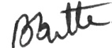
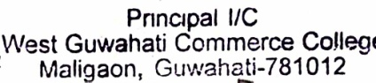

(Bhabananda Dutta)
Principal I/C & Secretary
West Guwahati Commerce College.
Maligaon,Baripara, Guwahati-12

