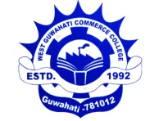

Maligaon, Baripara, Pandav Nagar, Guwahati-781012
Email Id: wgcc1992@gmail.com, englishdeptwgcc@gmail.com

Ref. No.: WGCC/MC/OFFICE/NOTICE/004/2023 Date- 26/04/2023

Notice

It is notified for B.Com 2nd semester students to prepare a project report on ENVIRONMENTAL STUDIES as a course curriculum. Total marks for the project report will be 30 marks (20 marks for project report and 10 marks for viva). The project report will be followed by a viva for the subject. The last date for submission of project report is 23rd May 2023, in the Department of Management. The viva for the same will be held on 23/04/2023 from 10 am onwards. Students are asked to prepare the project report on any of the following topics:
- The effect of Flood on road users.
- Environmental Pollution and its associated health Risk among residents of Baripara, Maligaon, Guwahati, Assam.
- Assessment of poor drainage system in Guwahati.
- Water supply planning.
- An Assessment of solid waste Disposal in residential buildings.
- Others.

Note : Only section A, Roll No. 1 to 120 will submitted.
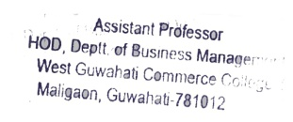

Dr. Iva Devi
Hod, Dept. of Management
West Guwahati Commerce College
Maligaon, Baripara, Guwahati-12

