Notable Activities of the

Internal Quality Assurance Cell
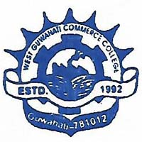

WEST GUWAHATI COMMERCE COLLEGE

MALIGAON, GUWAHATI, ASSAM-781012

- Orientation Programme on “E-Governance Cum e-College” organized by IQAC, West Guwahati Commerce College in collaboration in S. S Technologies on 4th March, 2022.

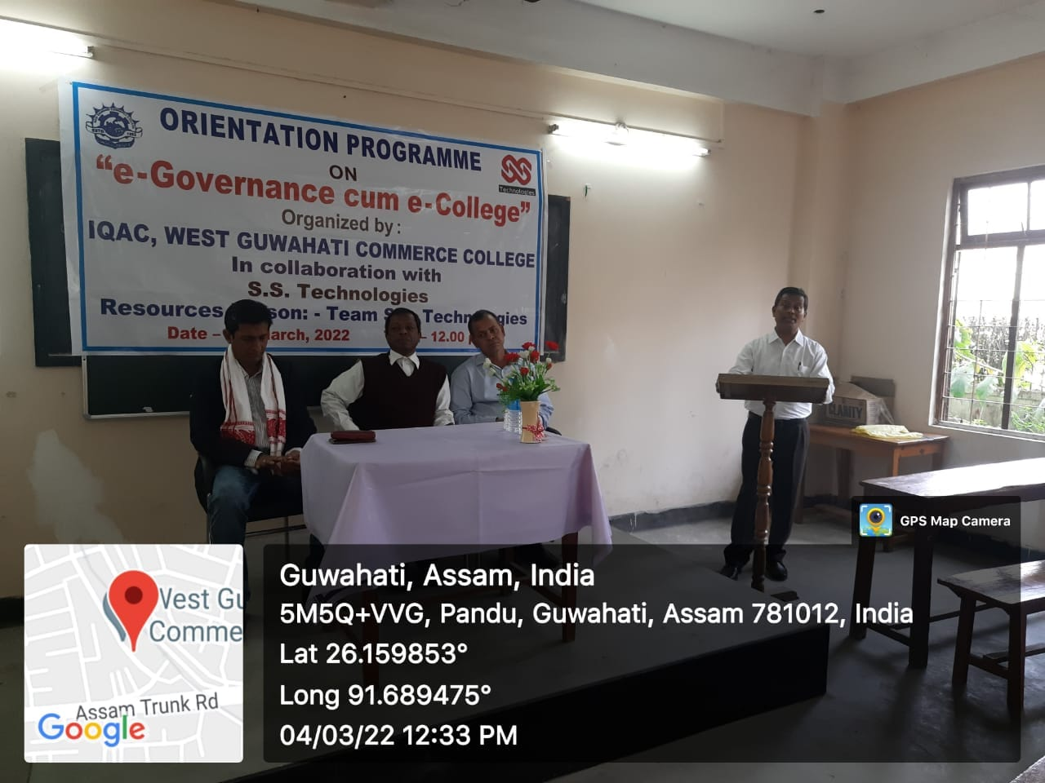
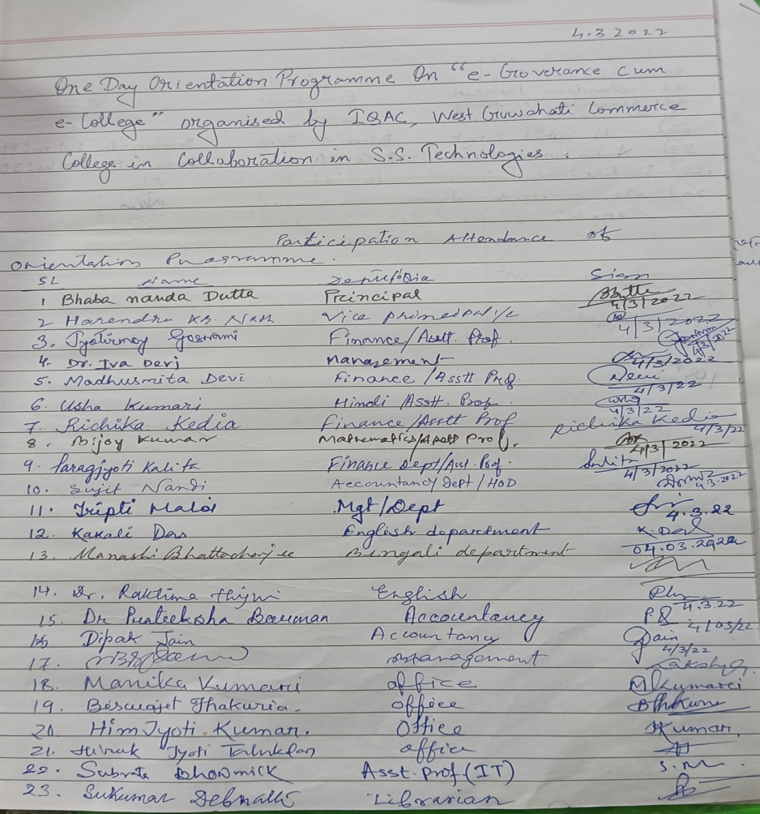

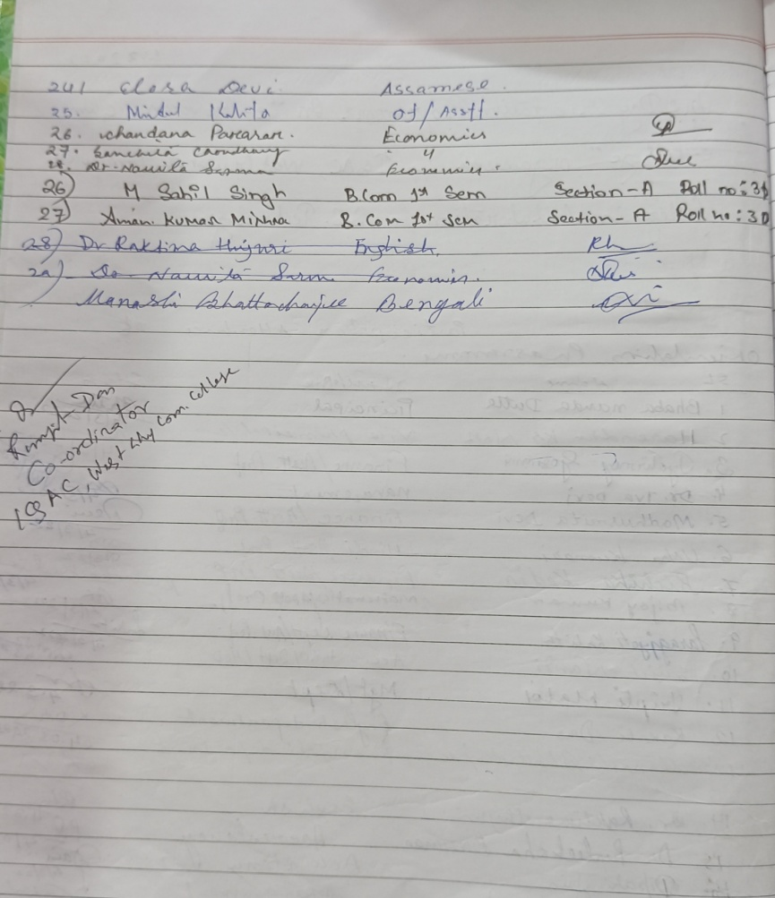
WORKSHOP ON – “ACADEMIC AND ADMINISTRATIVE AUDIT”
A workshop on "Academic and Administrative Audit" was held on 16th March,2022 at West Guwahati commerce college of Maligaon,Baripara. Prof. Jogen ch. Kalita, the member of NAAC State Committee cum HOD, Department of Zoology, G.U joined as the resource person in the very engaging workshop and motivated the participants of the entire West Guwahati Commerce College fraternity, with his enlightening words. Dr. Jyotish Goswami, president of Governing Body of west Guwahati Commerce College also took part in the event and offered his valuable speech on fulfilment of seven criteria for NAAC assessment in coming days. The workshop was attended by all the faculty, office staff, Alumni and NSS volunteers

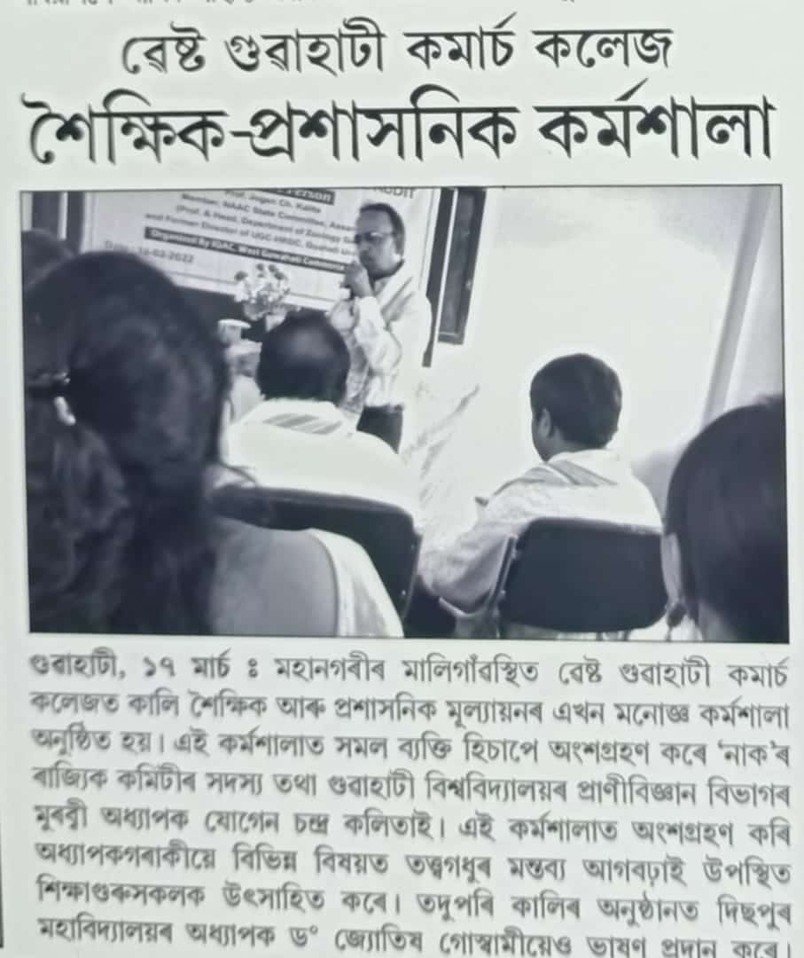

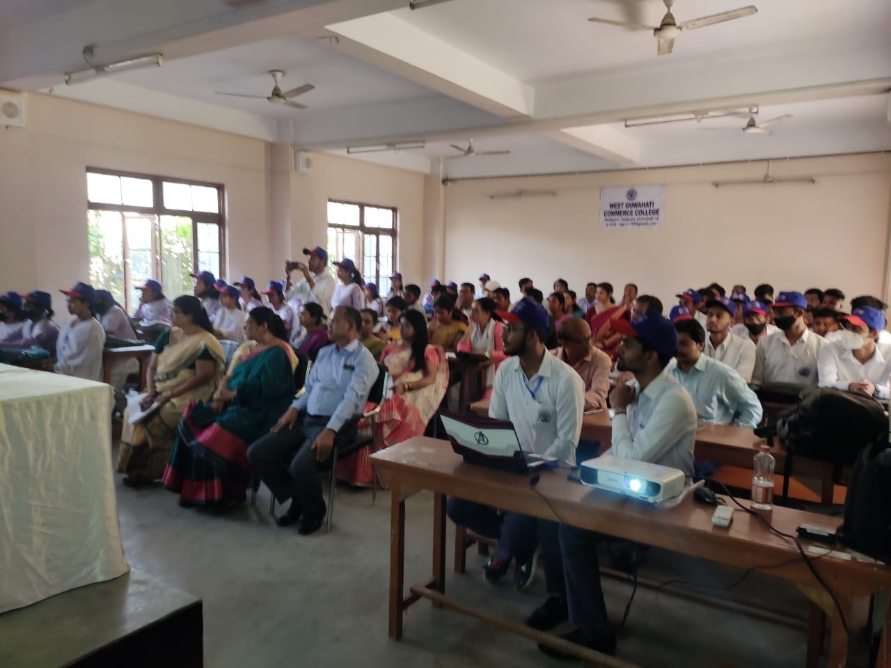
.

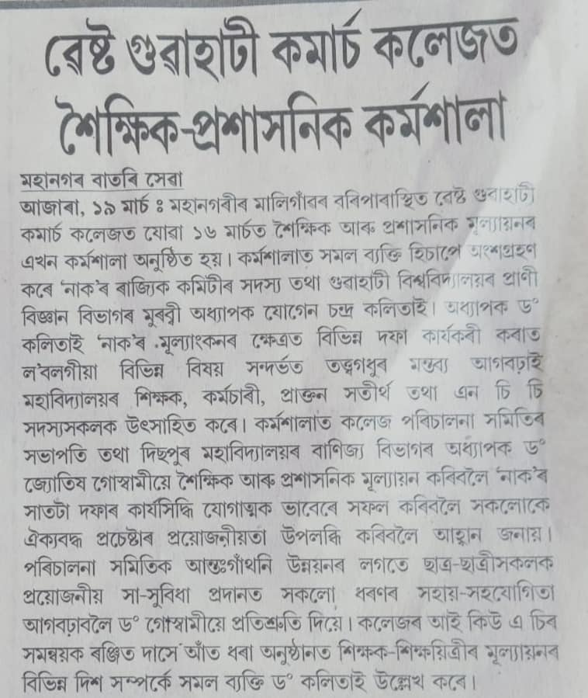

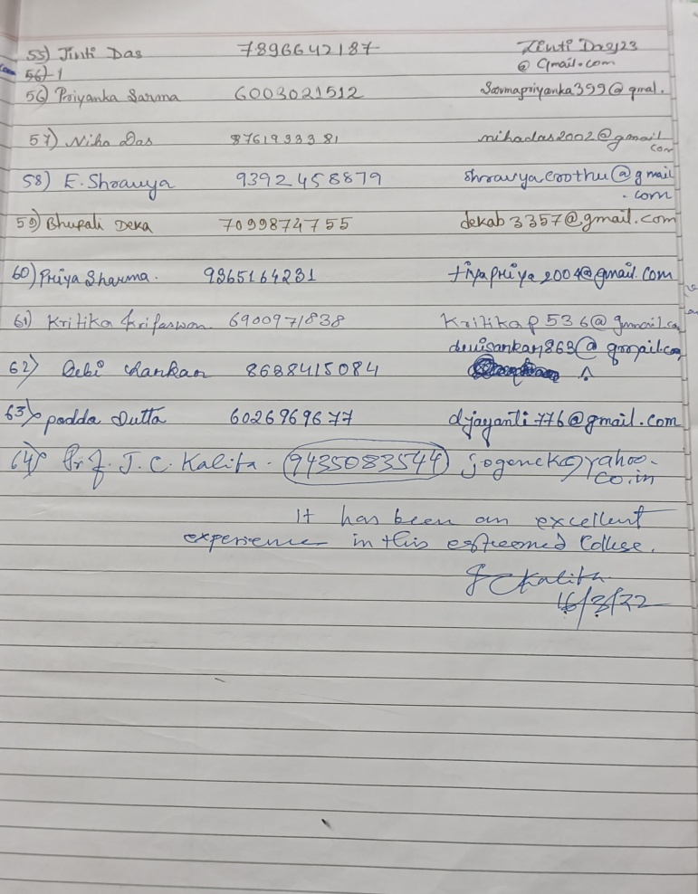
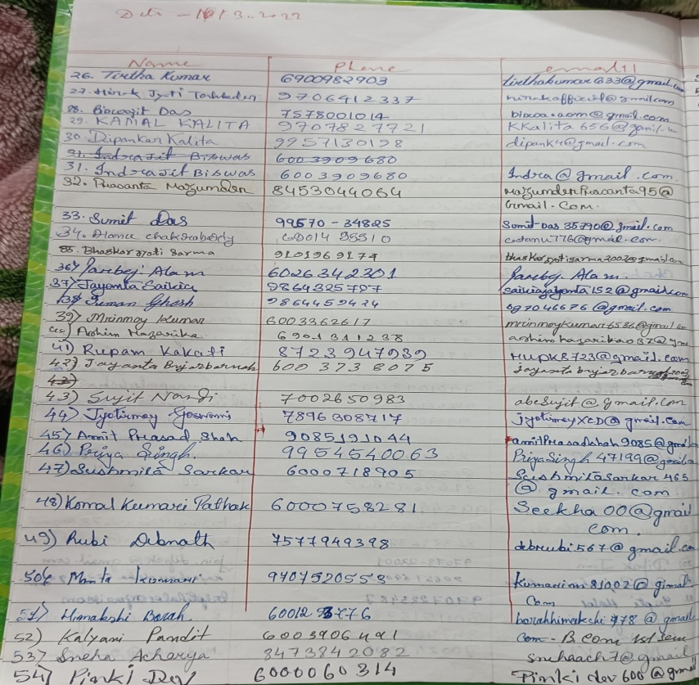

Swahid Diwas was observed at West Guwahati commerce college, Maligaon on 23rd of March, 2022 in memory of the scarifies made by the brave revolutionaries and great sons of India. The event was attended by all the faculty members, office staff and students along with the Principal i/c and vice-principal i/c . The program was inaugurated with lighting of the lamp by the honourable principal i/c of the college. The event got enriched with the notable words on the Martyrs and their sacrifies by the senior faculties,who has inspired all the present members along with the students. Everybody paid tribute to the Martyrs Bhagat singh, Sukhdev Thapar and Shivaram Rajguru. The event was concluded with a patriotic song by all the members present there.
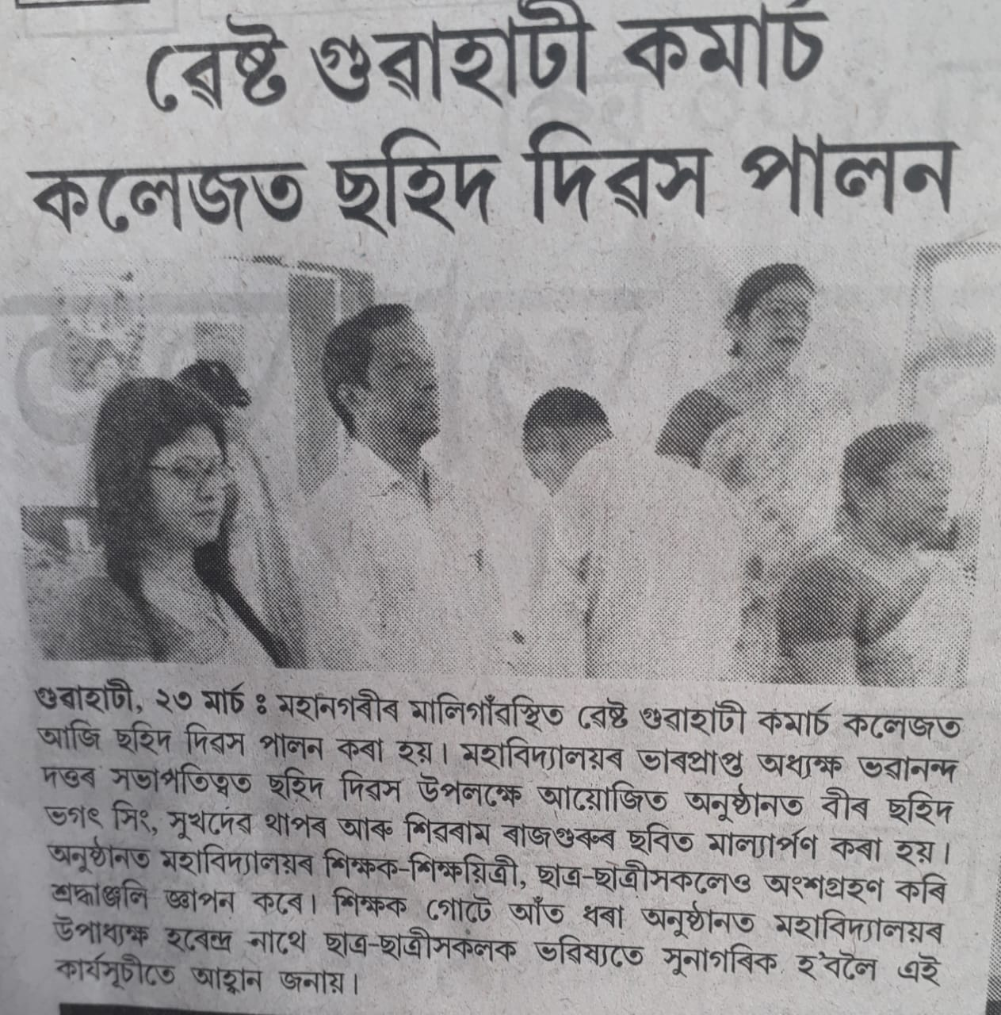
বিশ্ব স্বাস্হ্য দিৱস উপলক্ষে ৭/৪/২০২২ তাৰিখে ৱেস্ট গুৱাহাটী কমাৰ্চ কলেজত আভ্যন্তৰিন মান নিৰূপন কোষৰ উদ্যোগত আৰু পান্ডু এফ. আৰ.ইউ, জি.এন.আৰ.চি' ৰ সহযোগত বিনামূলীয়া স্বাস্হ্য পৰীক্ষা শিবিৰৰ আয়োজন কৰা হয়। অনুস্ঠানটো উদ্বোধন কৰে মহাবিদ্যালয়ৰ ভাৰপ্ৰাপ্ত অধ্যক্ষ ভবানন্দ দত্তই। পান্ডু এফ. আৰ. ইউ ৰ ডক্তৰ দীপ্তিৰেখা শৰ্মা, ড০ময়ুৰী বৰ্মন, ড০ ধনদা দাস, ড০হেমন্ত দাস তেখেতসকলে মূল বিষয়বস্তু "আমাৰ পৃথিৱী আমাৰ স্বাস্হ্য " ৰ ওপৰত সজাগতা মূলক ব্যাখ্যা আগবঢ়াই। আভ্যন্তৰিন মান নিৰূপন কোষৰ সমন্বয়কে আত ধৰা অনুস্ঠানটোত শিক্ষক -শিক্ষয়ত্রী, ছাত্ৰ-ছাত্ৰী, ৱাৰ্ড নং ৫ ৰ কাউন্সিলৰ সন্জয় কুমাৰ দাস আৰু ৱাৰ্ড মেম্বাৰ জুনু কুমাৰী উপস্হিত থাকে।
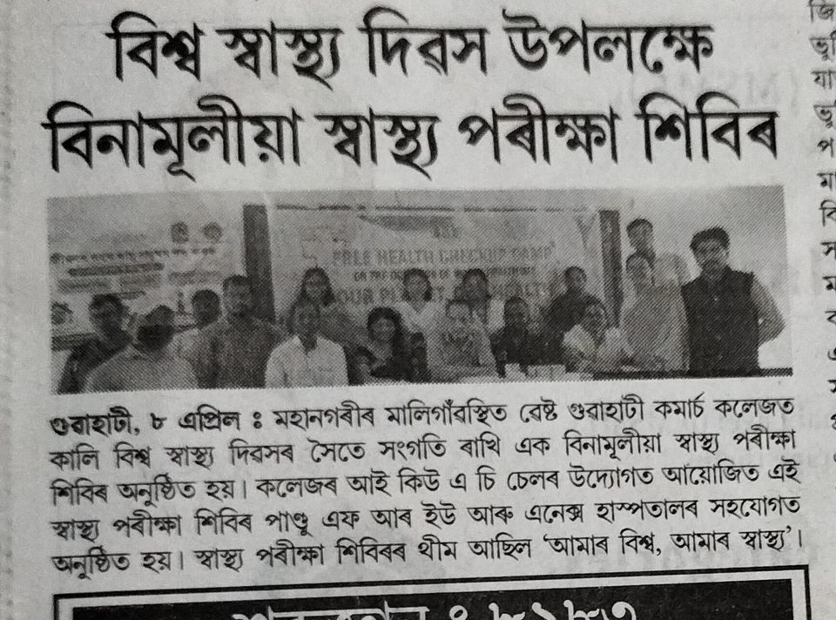

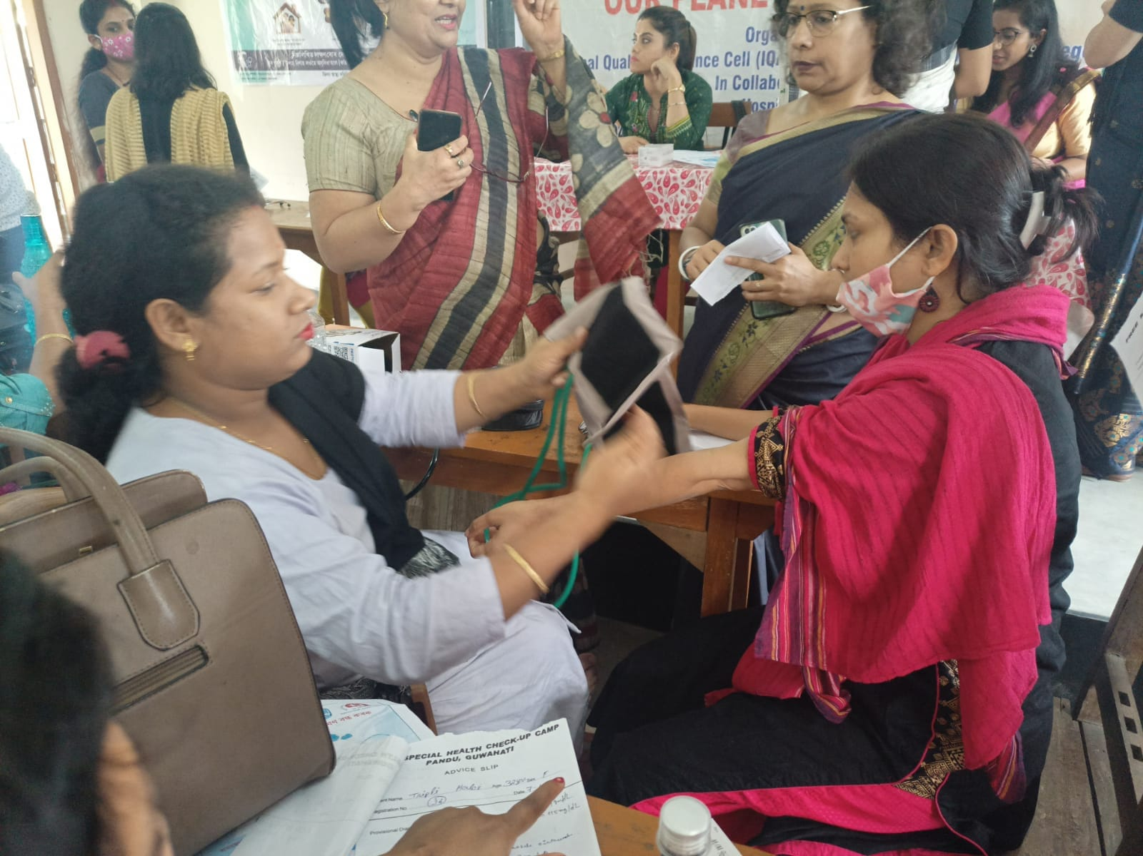
PRE BIHU CELEBRATED AT WEST GUWAHATI COMMERCE COLLEGE
A day long Pre Bihu programme was celebrated on 13th March, 2022 at West Guwahati Commerce College, Baripara, Guwahati by the teachers and students with much magnificence. The Bihu flag was hoisted by Mrs Lipi Saikia, director of Instute of Computer Association, Maligaon,followed by a plantation programme. This grand occasion was celebrated in the open field of the college premises whereby Bihu husori, Bihu songs and Assam's rich cultural heritage was showcased in the form various folk performances of the North East India. Dr Jyotish Goswami, the president of the Governing Body of West Guwahati Commerce College emphasized on the importance of celebrating Bihu in educational institutions in his encouraging speech.He pointed that people welcome the spring season in Assam Rongali Bihu and pray for bountiful and rich harvest through this festival. Mr. Bhabananda Dutta, the principal Incharge of the college also urged the students to take forward the legacy of our rich cultural heritage. Mr, Harendra Kr Nath, the vice principal elaborated on Bihu and it's significance. Kamal Kalita, the president of the alumni association of the college enthused the students and the whole audience with a poem and also anchored the programme along with Atanu Chakraborty, a B.com student of West Guwahati Commerce College. Dr Raktima Huzuri ,convenor of celebration committee expressed that Rongali Bihu, the harvest festival of Assam inspired unbounded joy and enthusiasm, expressed through intoxicating songs and dances. Dr. Iva Devi, co ordinator of IQAC cell offered her vote of thanks.
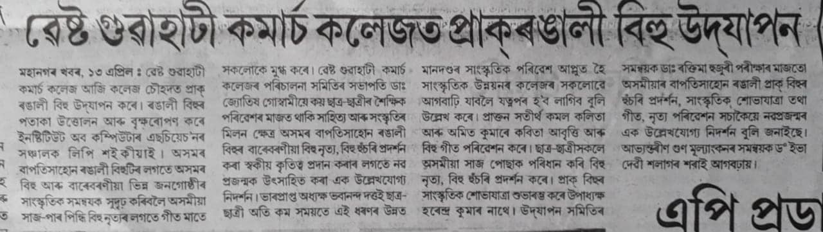

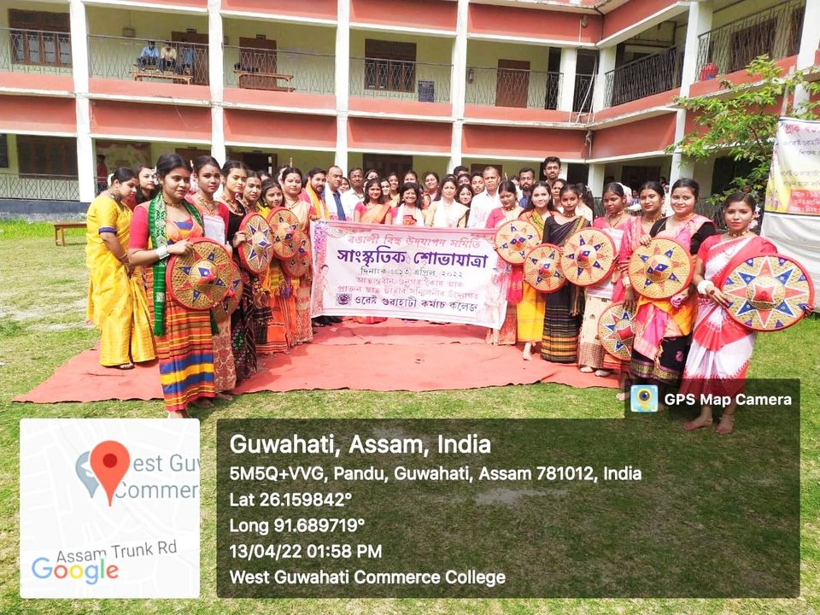

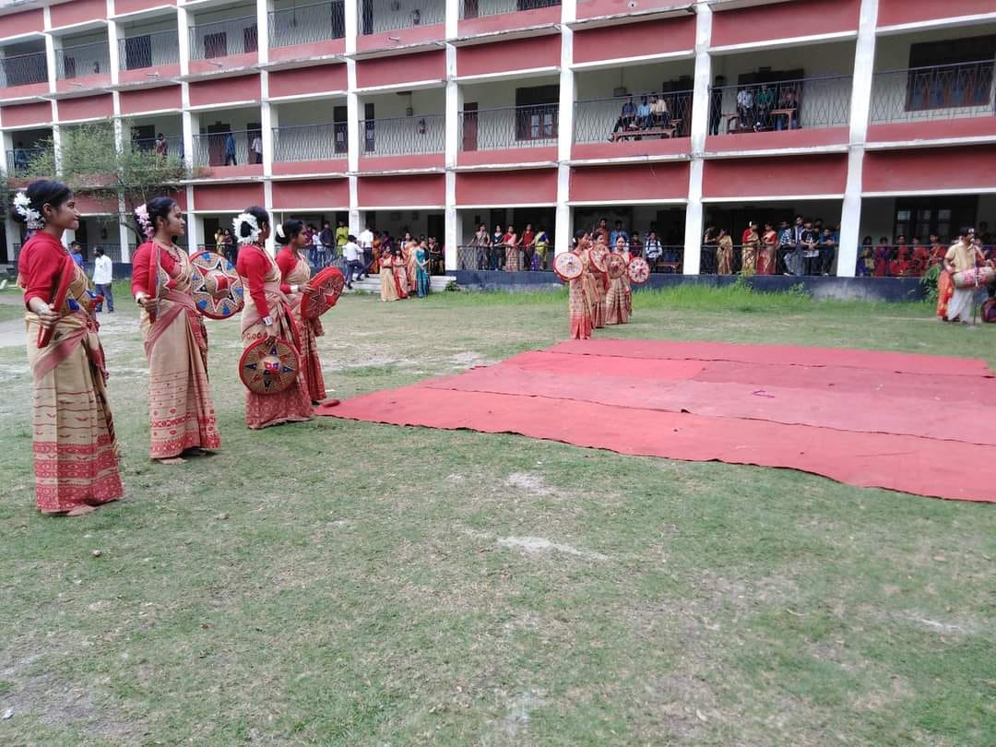

20TH JUNE 2022 OBSERVED KALAGURU BISHNUPRASAD RABHA DIVAS AT WEST GUWAHATI COMMERCE COLLEGE PREMISES
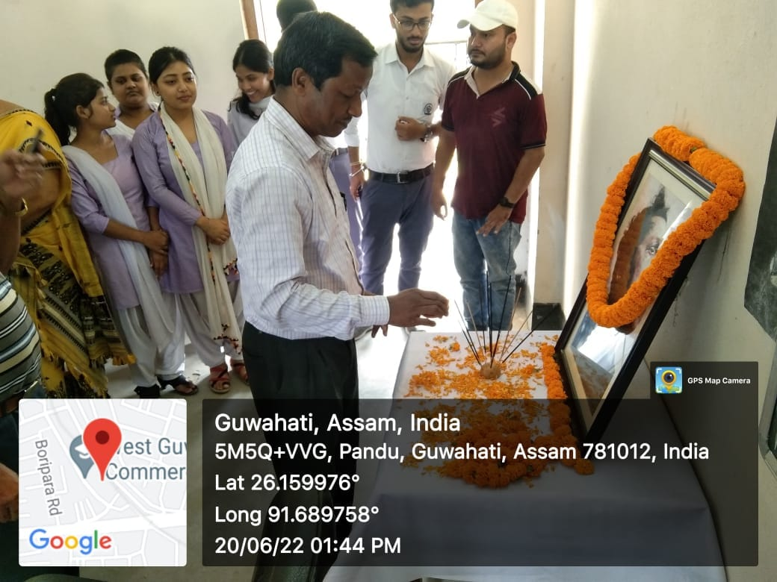

31ST FOUNDATION DAY

Today West Guwahati Commerce College celebrated its 31st Foundation Day and also launched three journals by honourable President Dr. Jyotish Goswami. The celebration was started with the Flag hoisting by our honourable Principal Mr. Bhabananda Dutta along with the faculty. Shortly thereafter lighting of the lamp was followed; an air of happiness could be felt in the crowd. Different songs and ballads were performed by the students received applauses and praises multiplied their happiness. Excitement and enthusiasm shown by the crowd truly made our day.

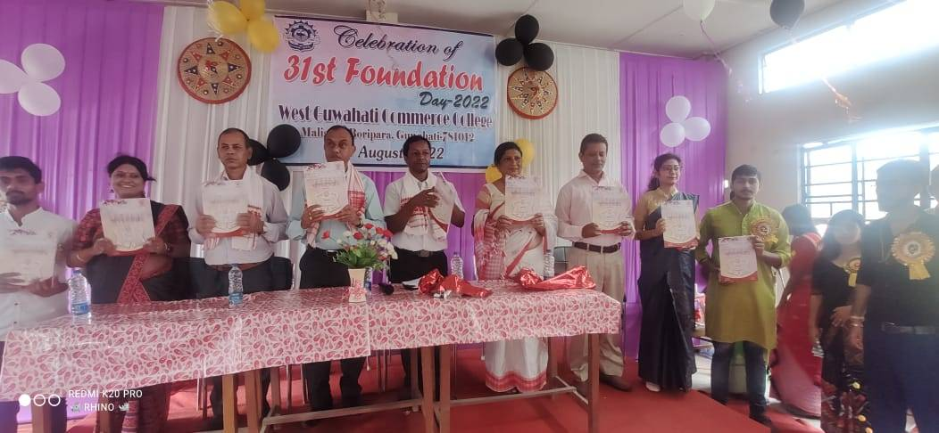

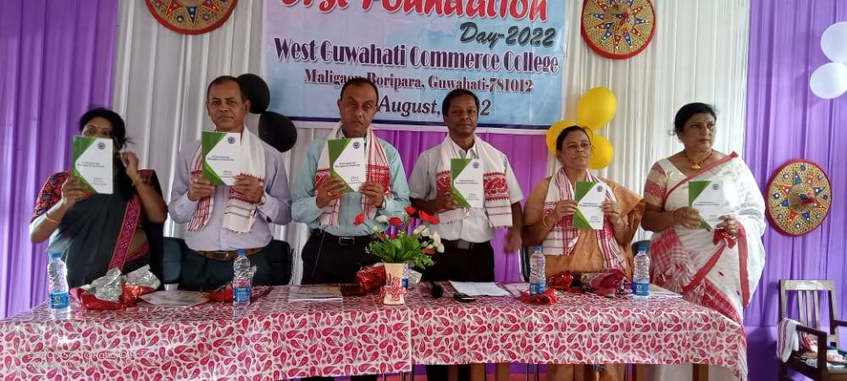
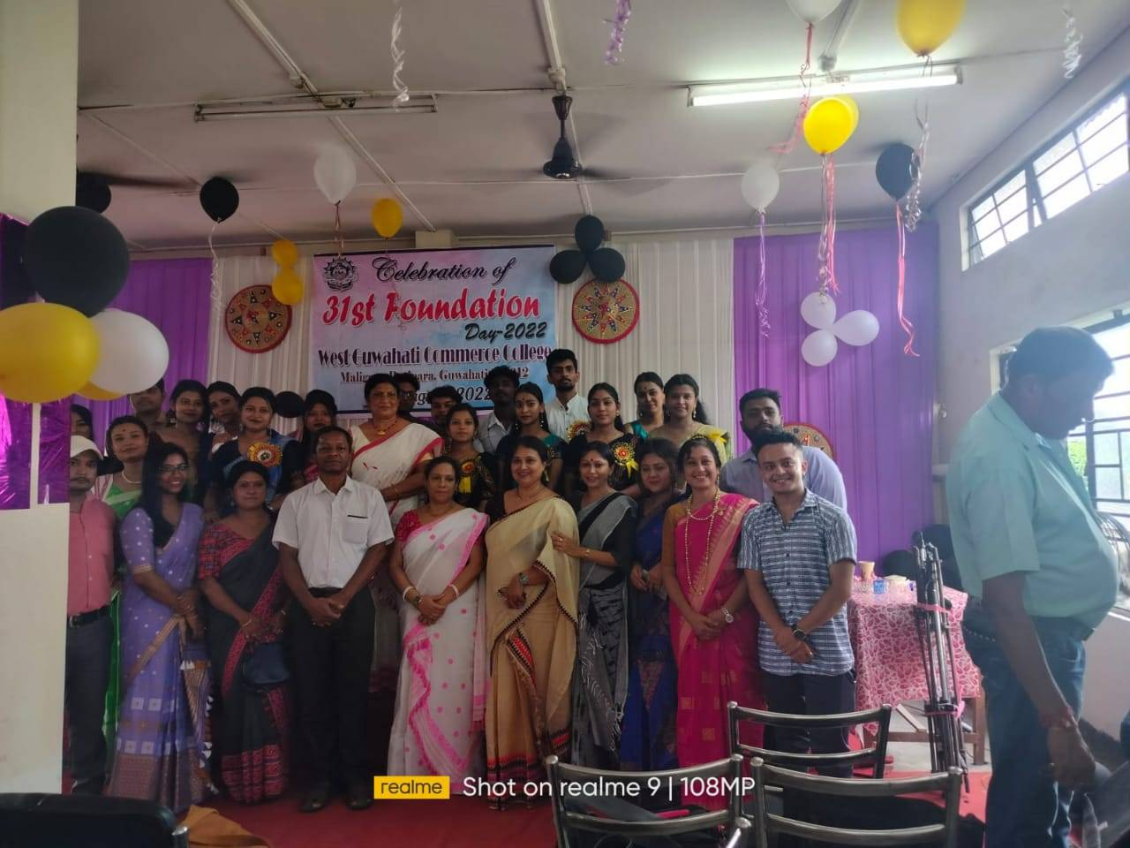

LECTURE ON –“REVISING NAAC ACCREDITATION PROCESS”
A Lecture on "Revising NAAC Accreditation Process" was held on 23rd September,2022 at West Guwahati commerce college, Maligaon,Baripara. Prof. Utpal Sarma, the member of NAAC State Committee cum HOD, Department of instrumentation & USIC, G.U joined as the resource person in the very engaging lecture and motivated the participants of the entire West Guwahati Commerce College fraternity, with his enlightening words.
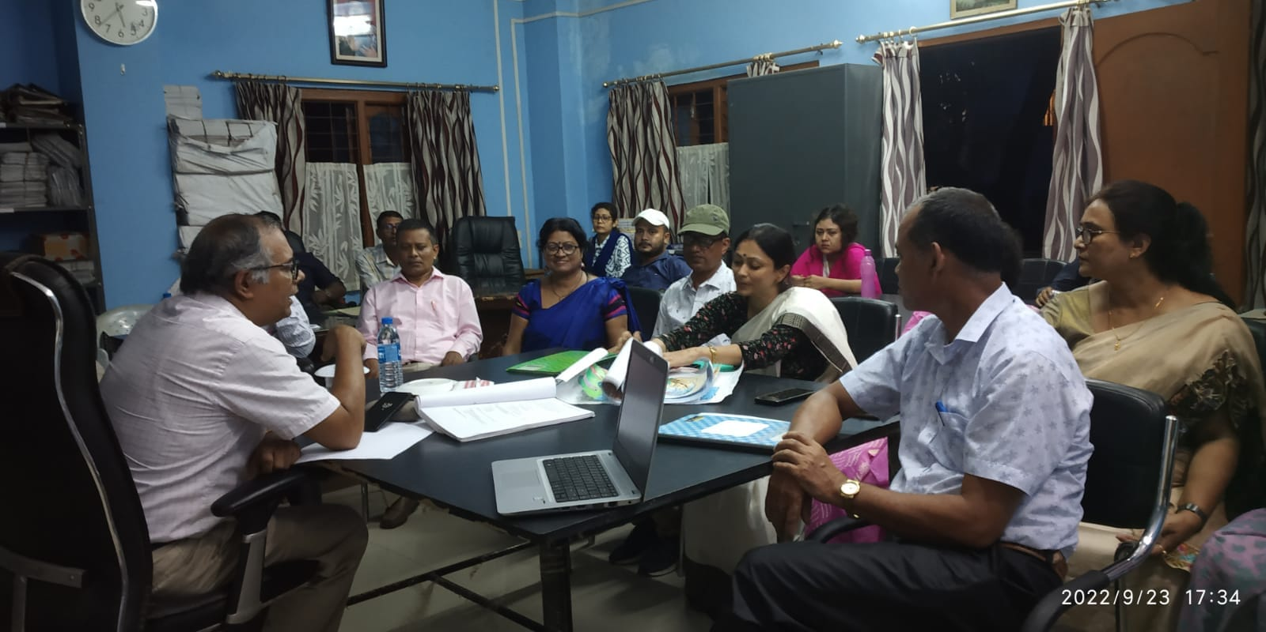

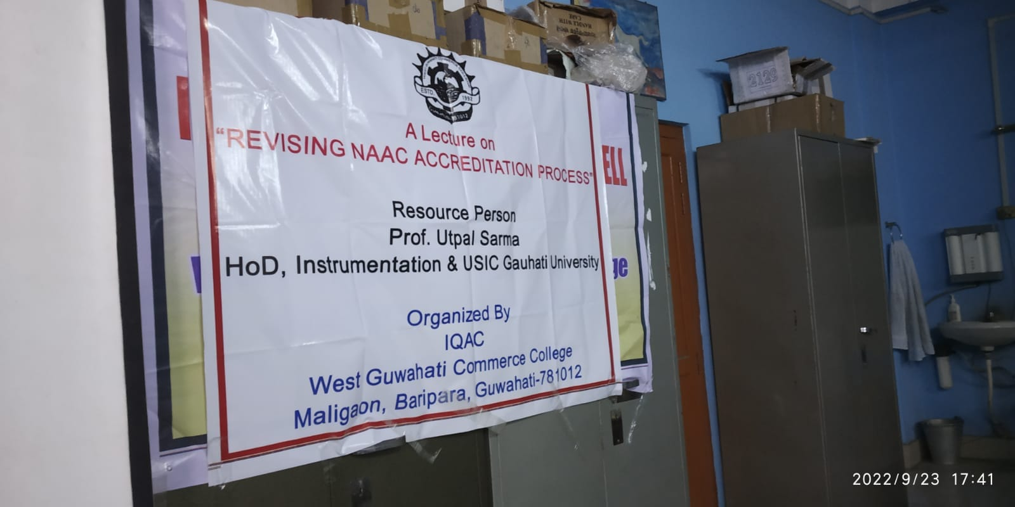
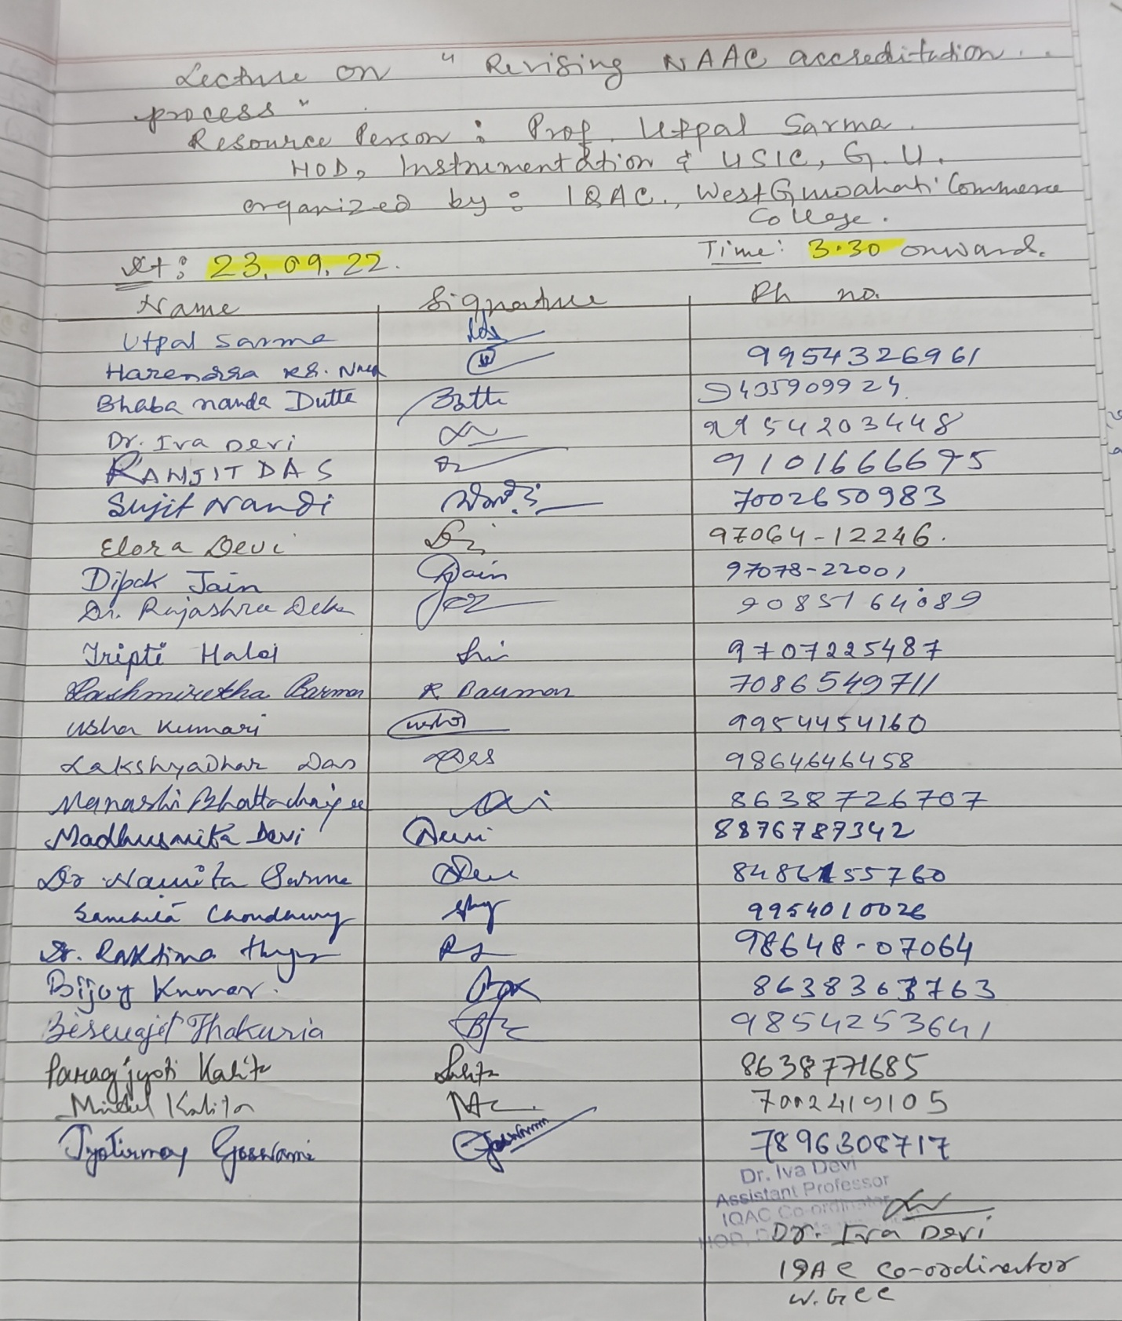

WORKSHOP ON SELF DEVELOPMENT
A workshop on 'Self Development' is held on 29-09-2022, Some of our proud students of B.Com 5th Semester, Akash Sharma and his team successfully conducted the workshop under the guidance of IQAC, WGCC.

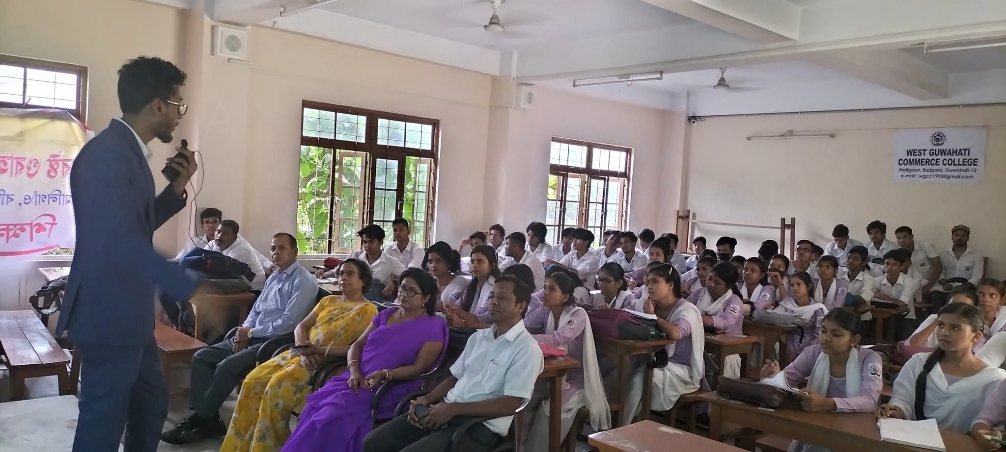

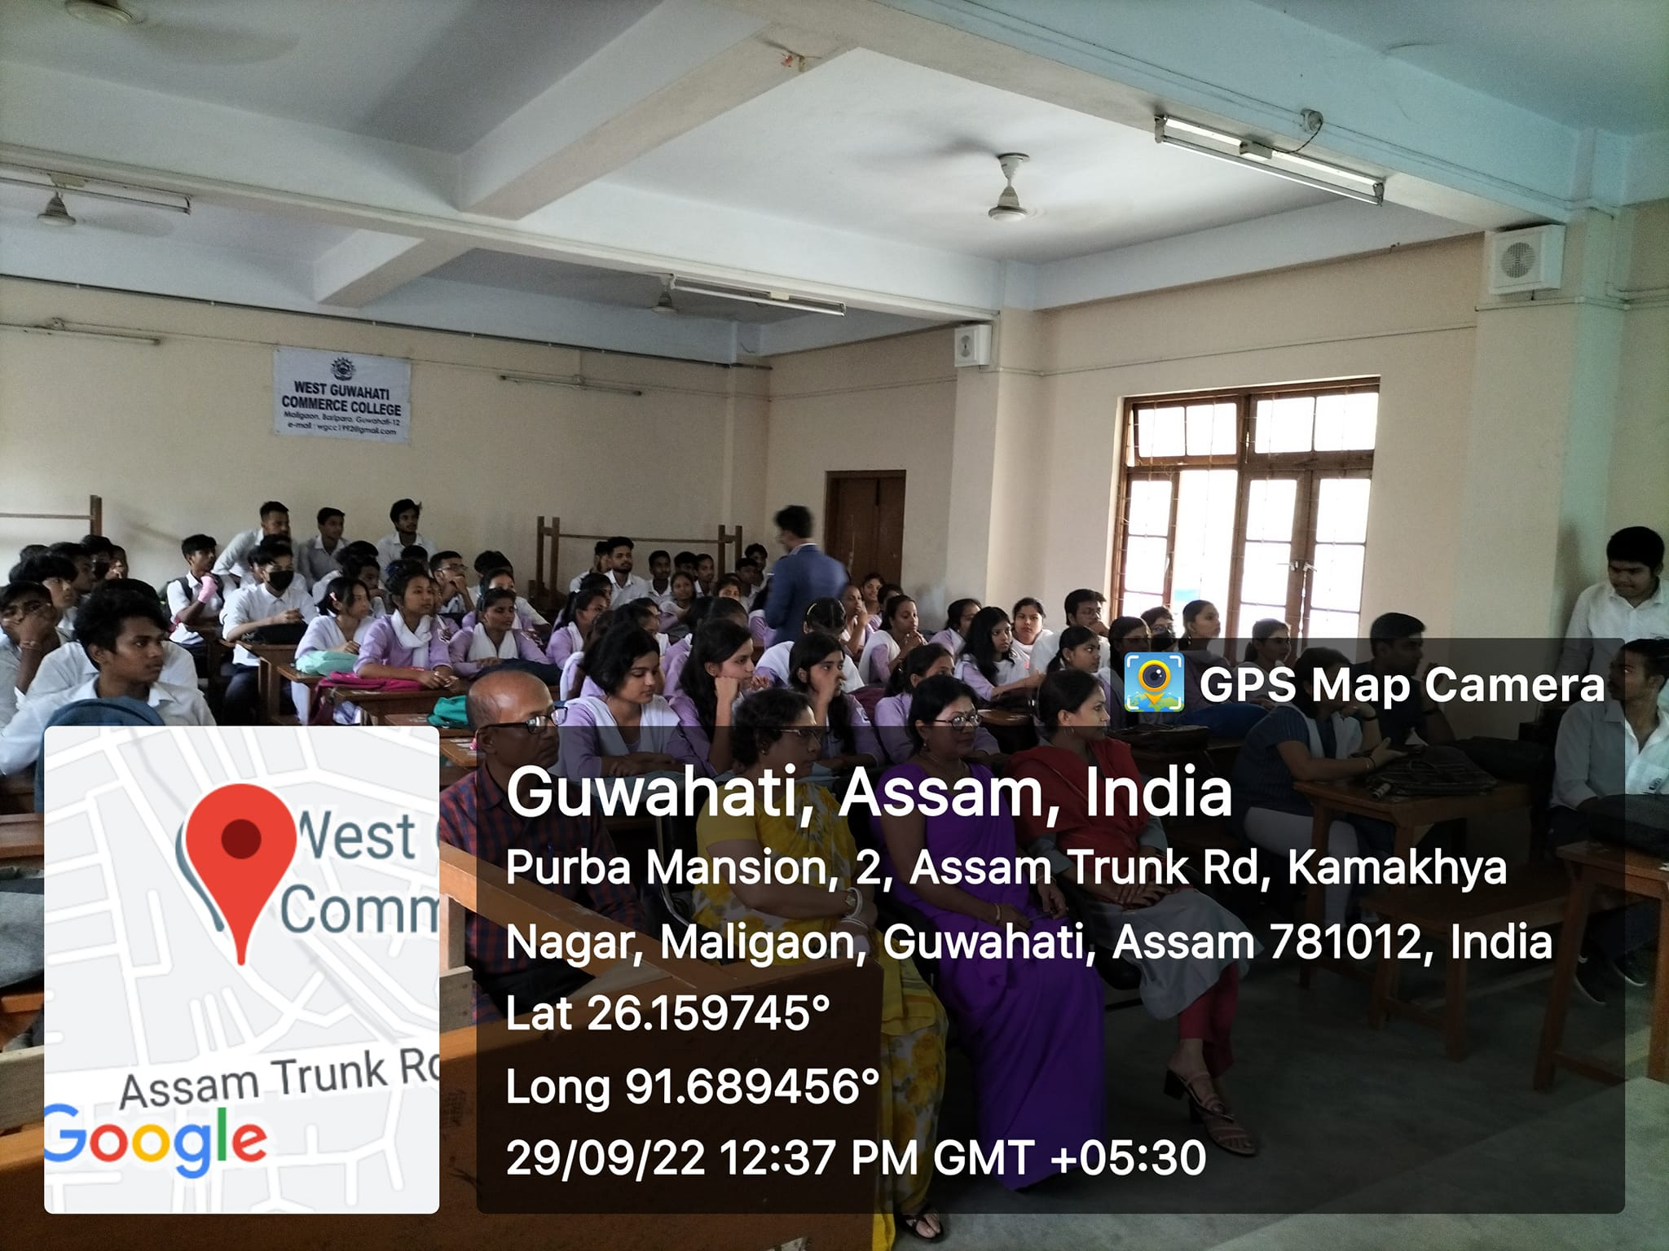
মহাবীৰ লাচিতৰ ৪০০ বছৰীয়া জন্ম-জয়ন্তী উদ্ যাপন ৱেস্ট গুৱাহাটী কৰ্মাচ কলেজত। জন্ম-জয়ন্তী উৎসৱৰ সৈতে সংগতি ৰাখি ২৫-১১-২০২২ তাৰিখে কলেজৰ বাকৰিত চাফাই অভিযান ...
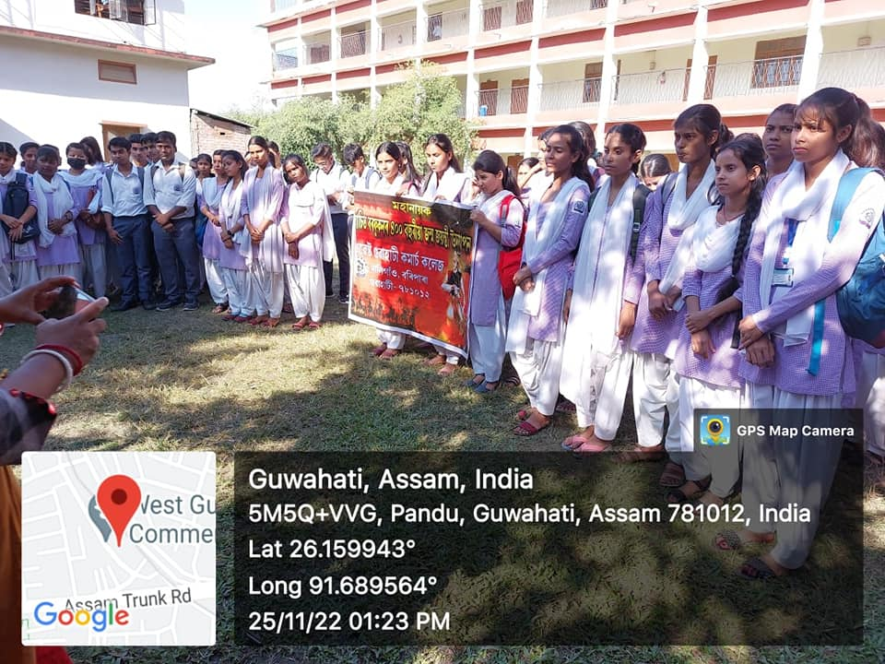
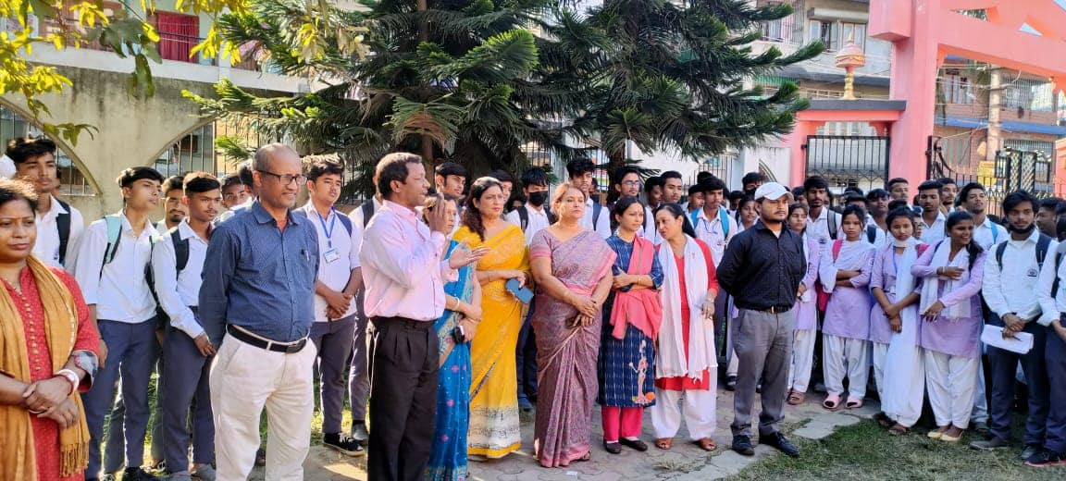

- Visited our college today Dr. Debahari Talukdar (Controller of examination , GU) ... Some glimpses
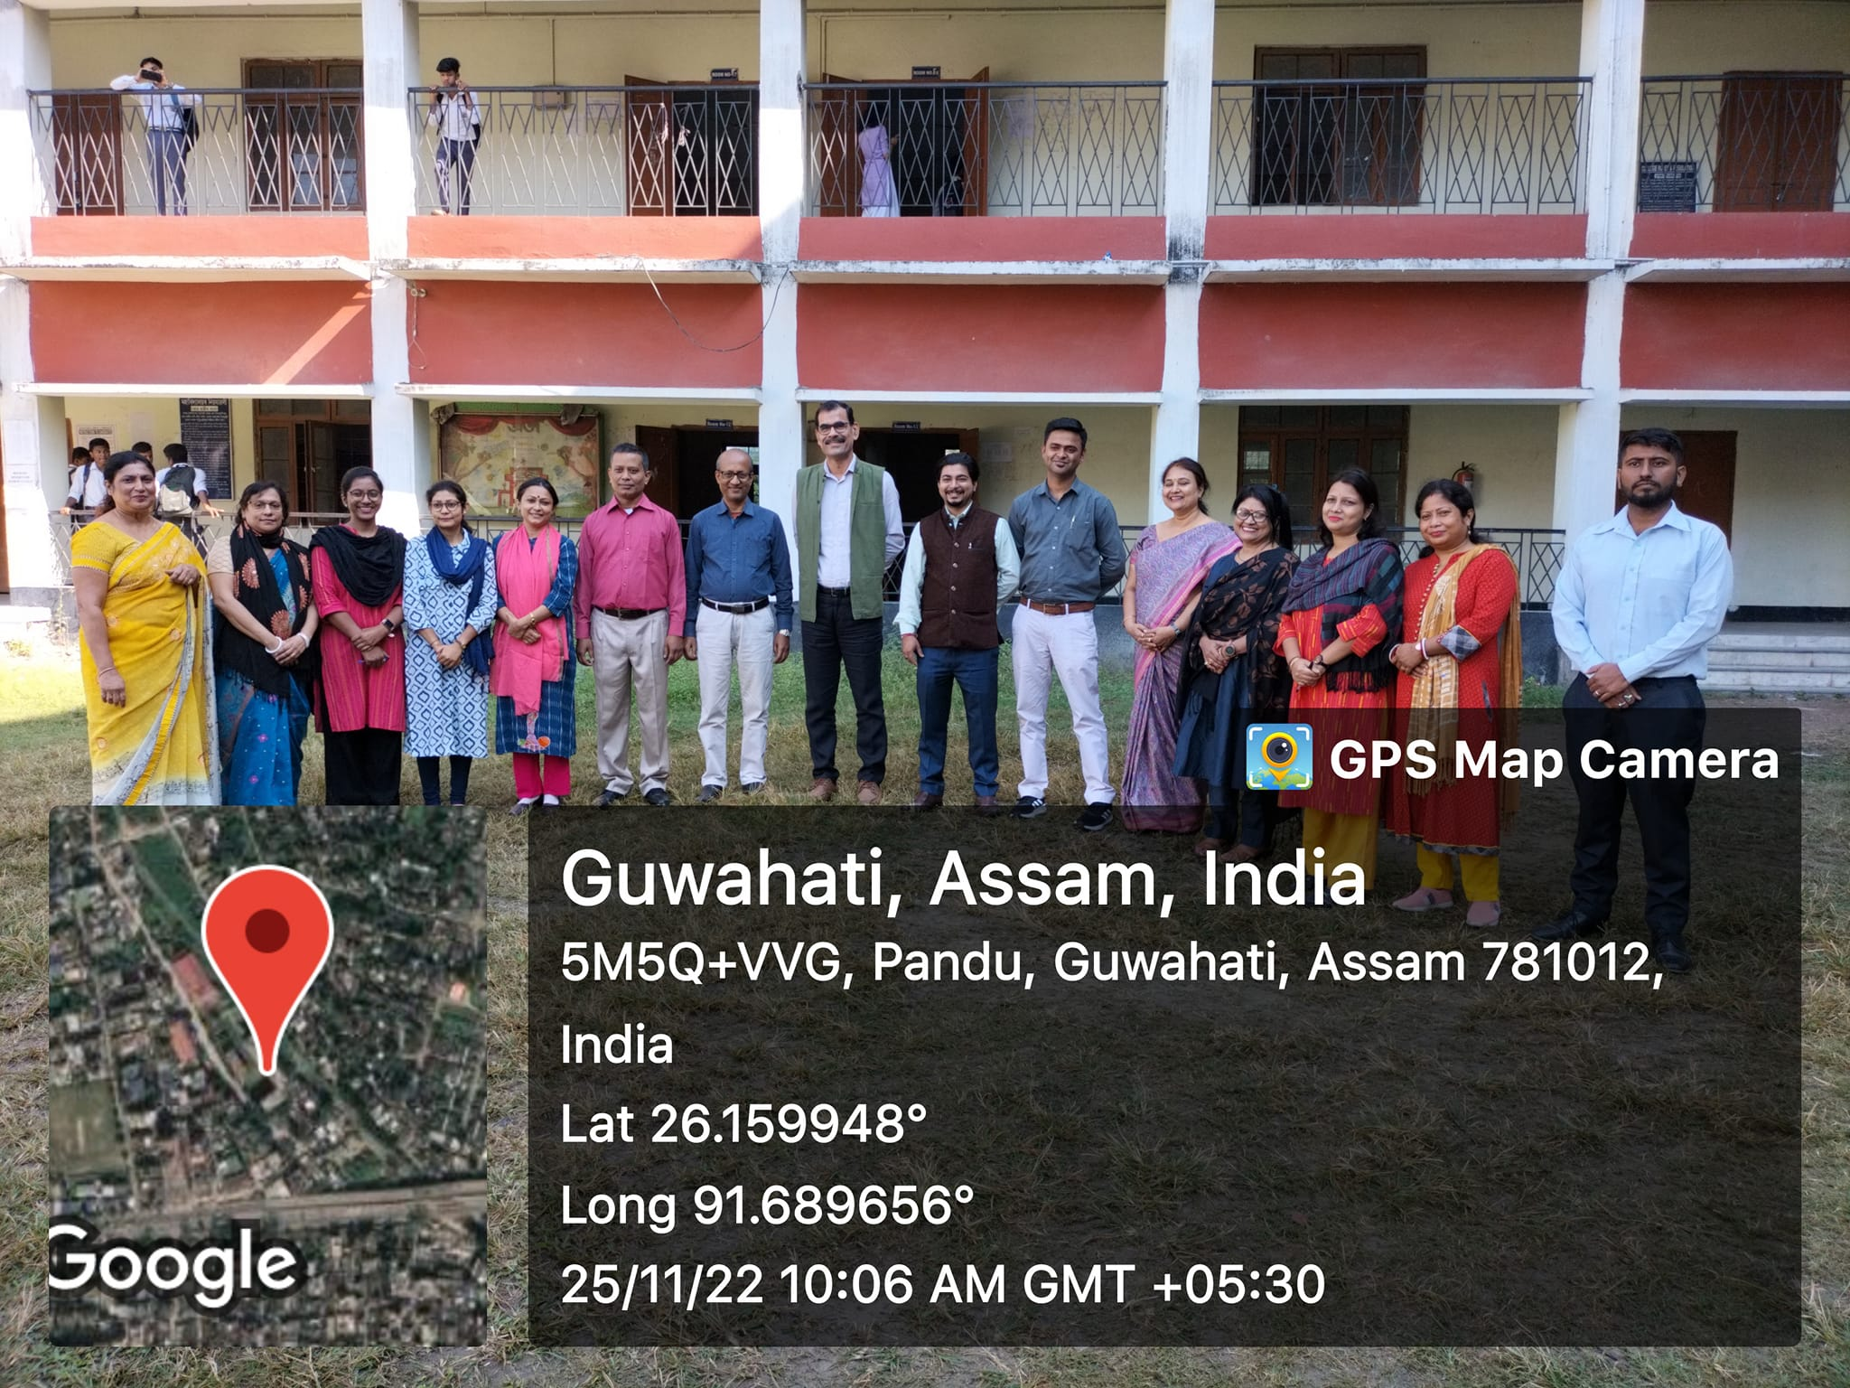
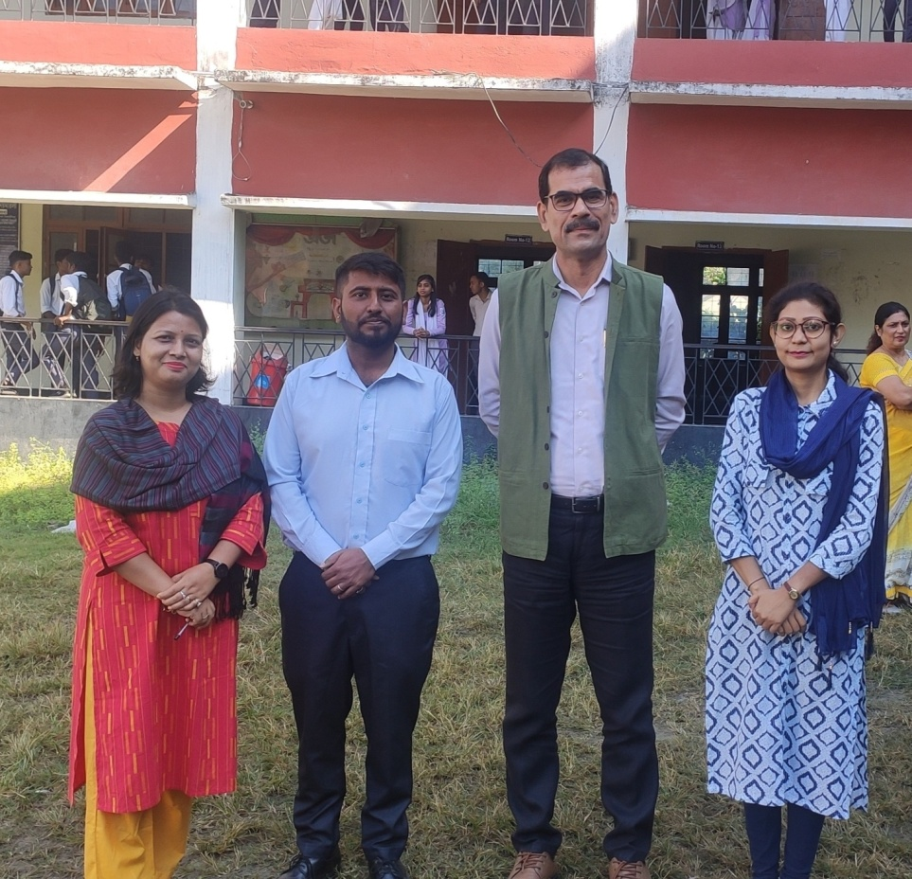

WOSRKSHOP ON “PREPARATION OF SSR FOR NAAC ACCREDITATION”
A Workshop on "Preparation of SSR for NAAC Accreditation" was held on 17th December, 2022 at West Guwahati commerce college, Maligaon,Baripara. Beltola College' A team of IQAC , joined as the resource person in the very engaging workshop motivated the participants of the entire West Guwahati Commerce College fraternity, with his activity.
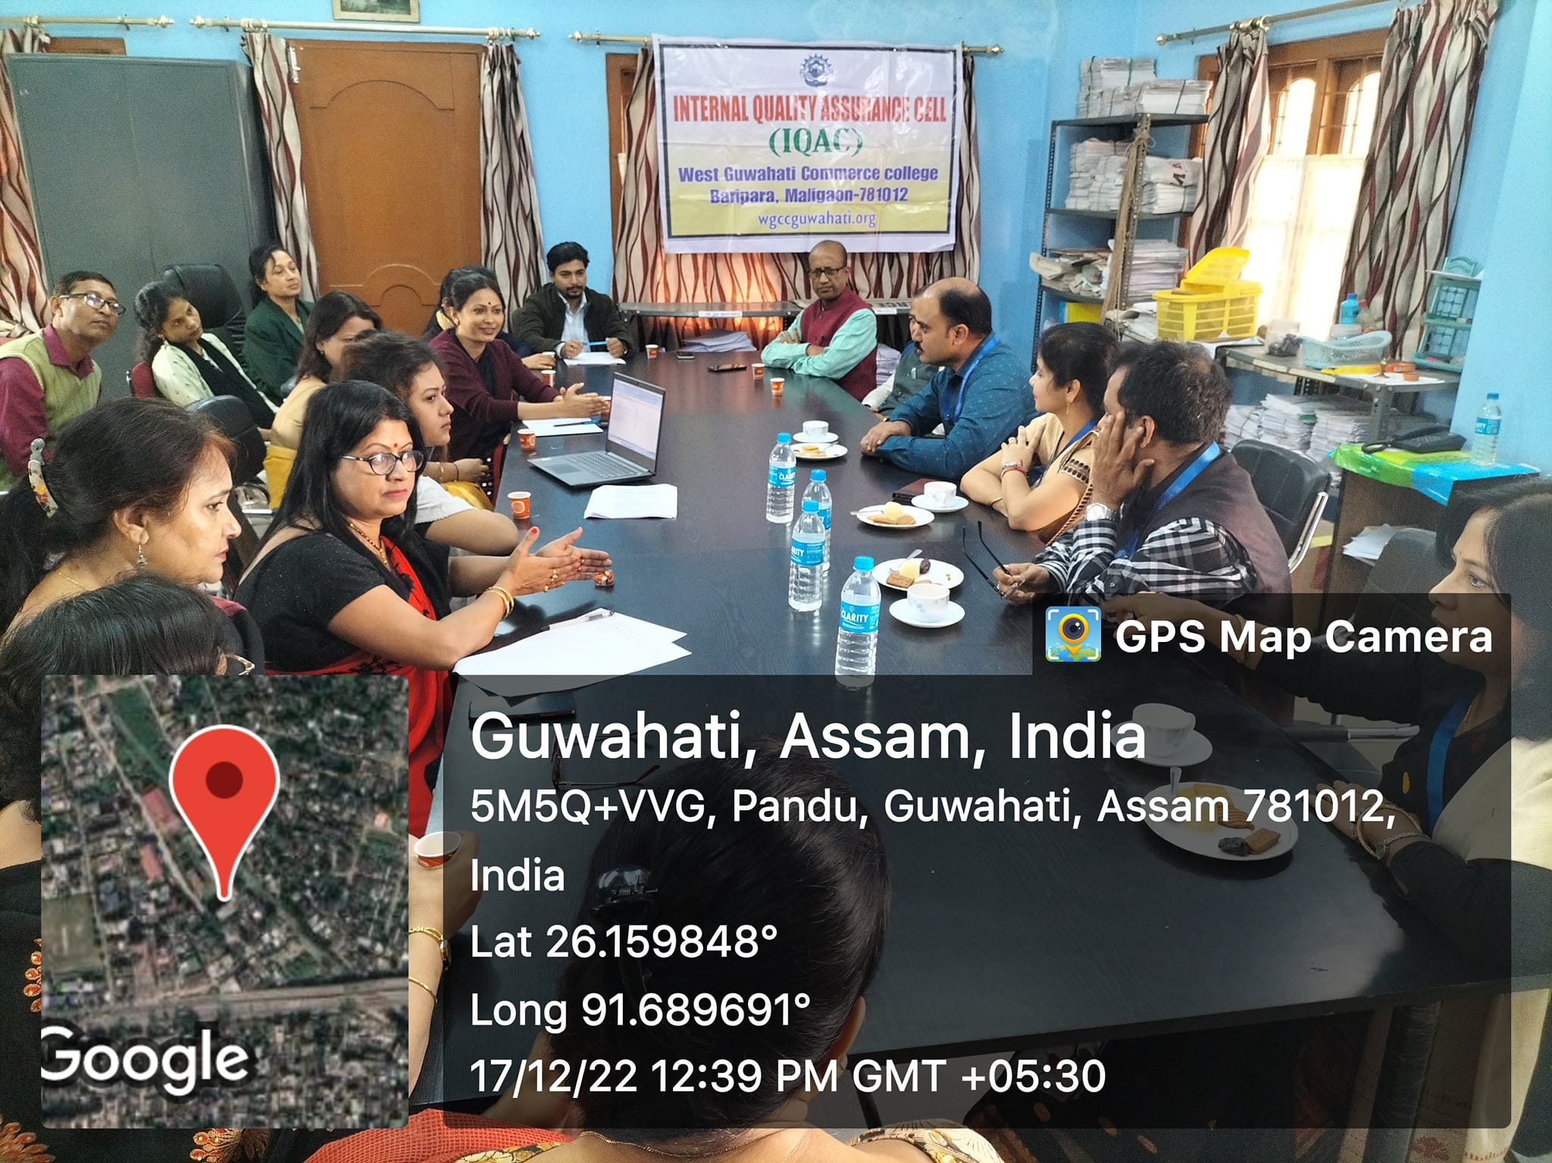

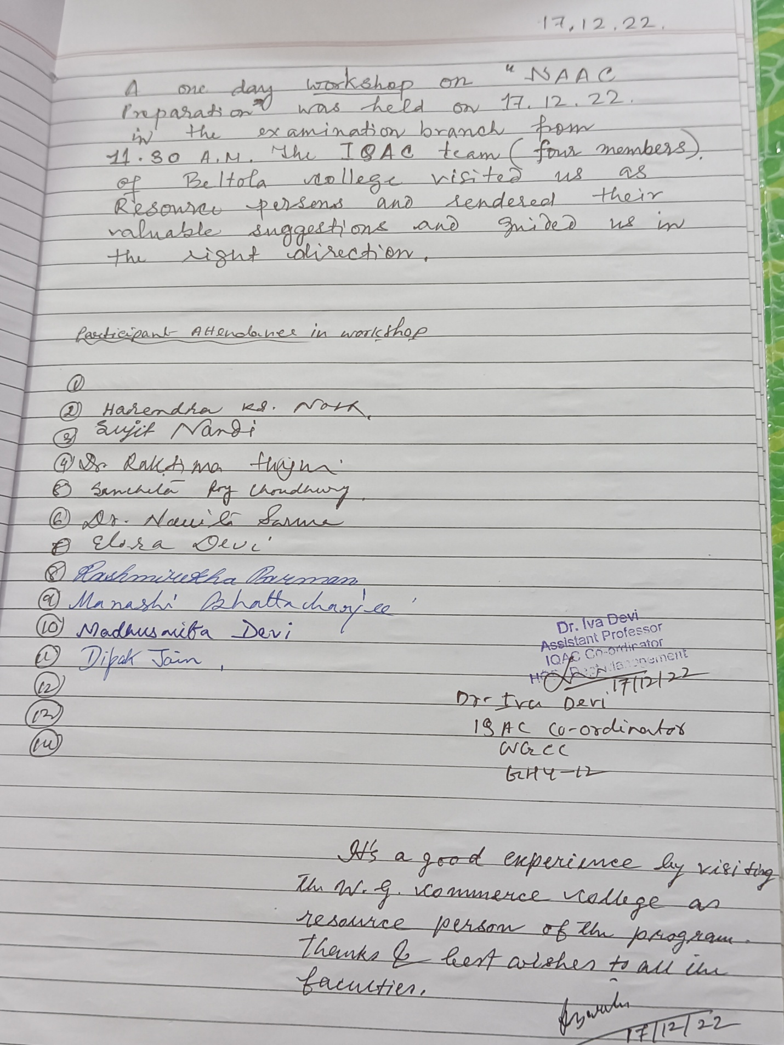

FREE EYE CHECK UP ORGANISED

West Guwahati Commerce College, IQAC & NSS organised a free Eye Check up Camp in collaboration with ASG Eye Hospital Pvt.Ltd, paltanbazar, Guwahati

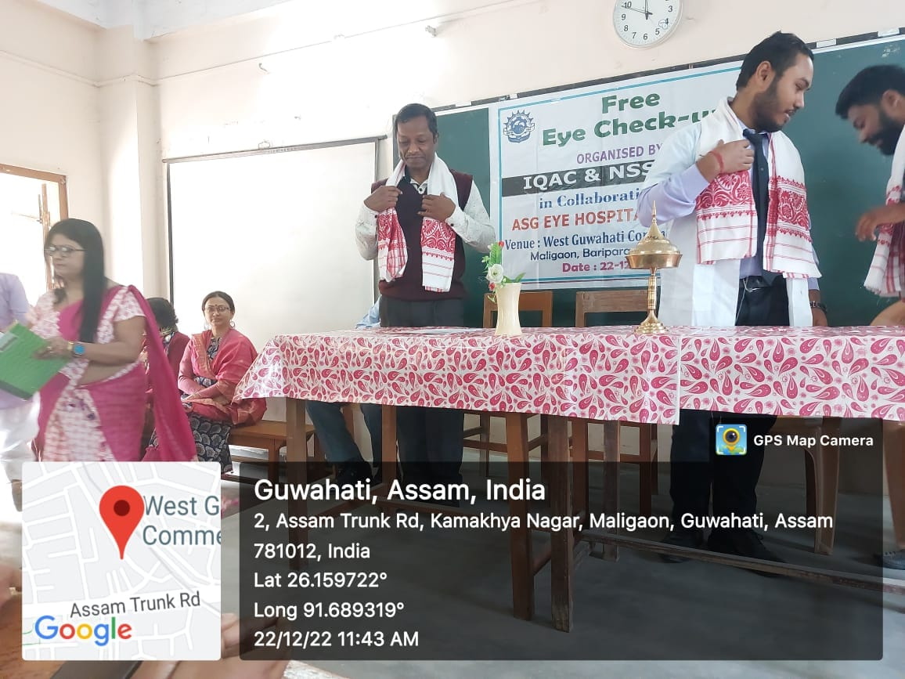

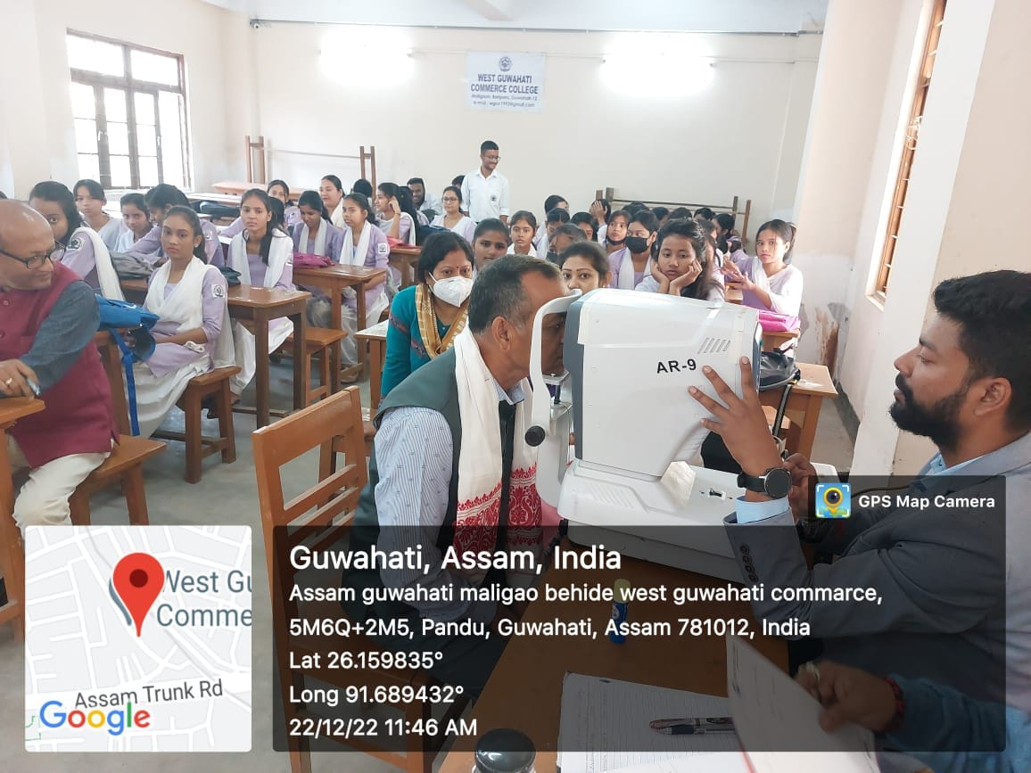

+9

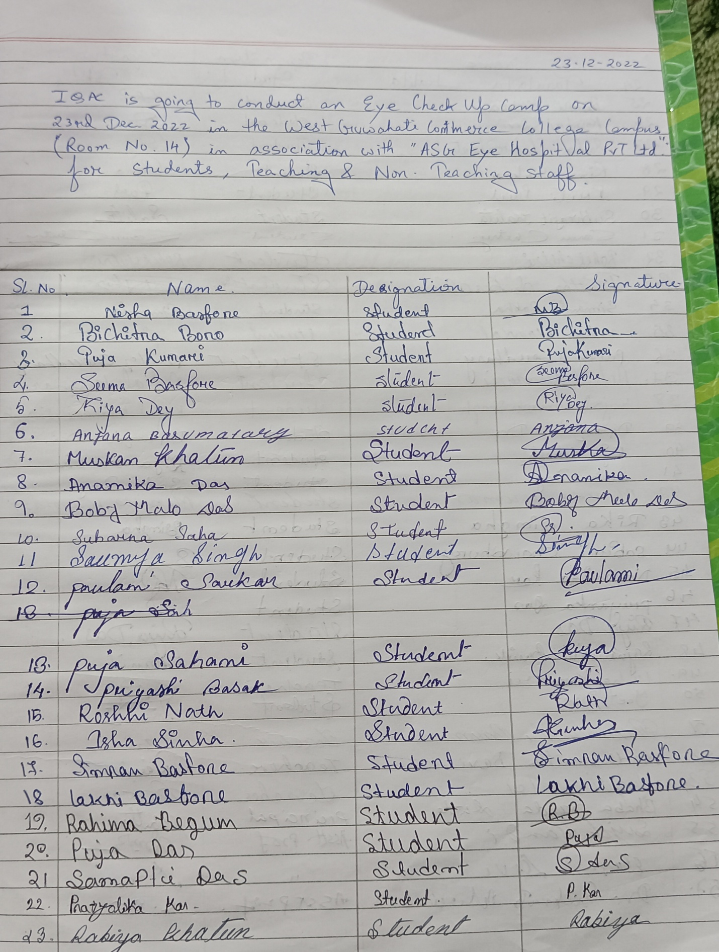

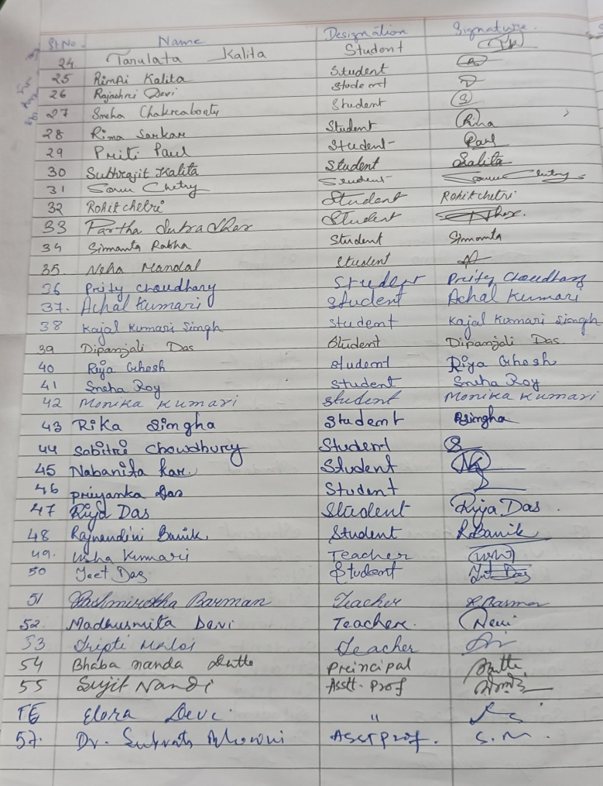

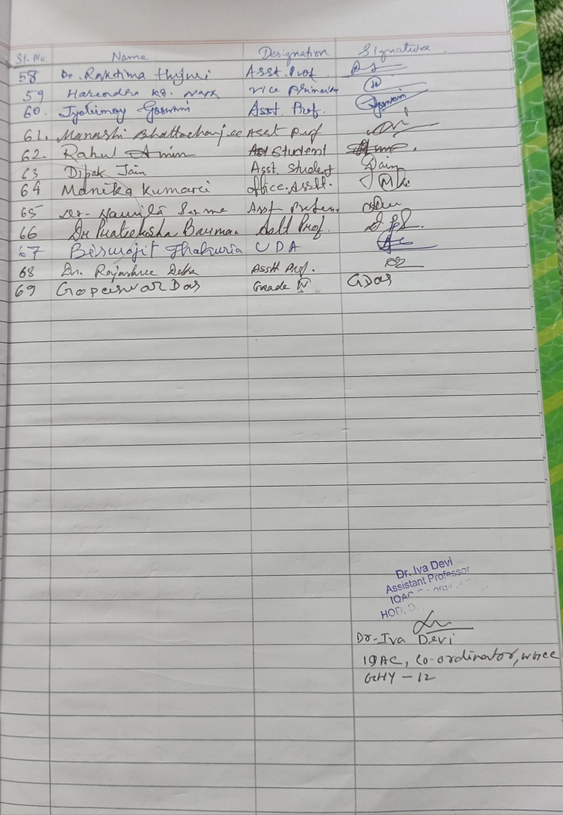
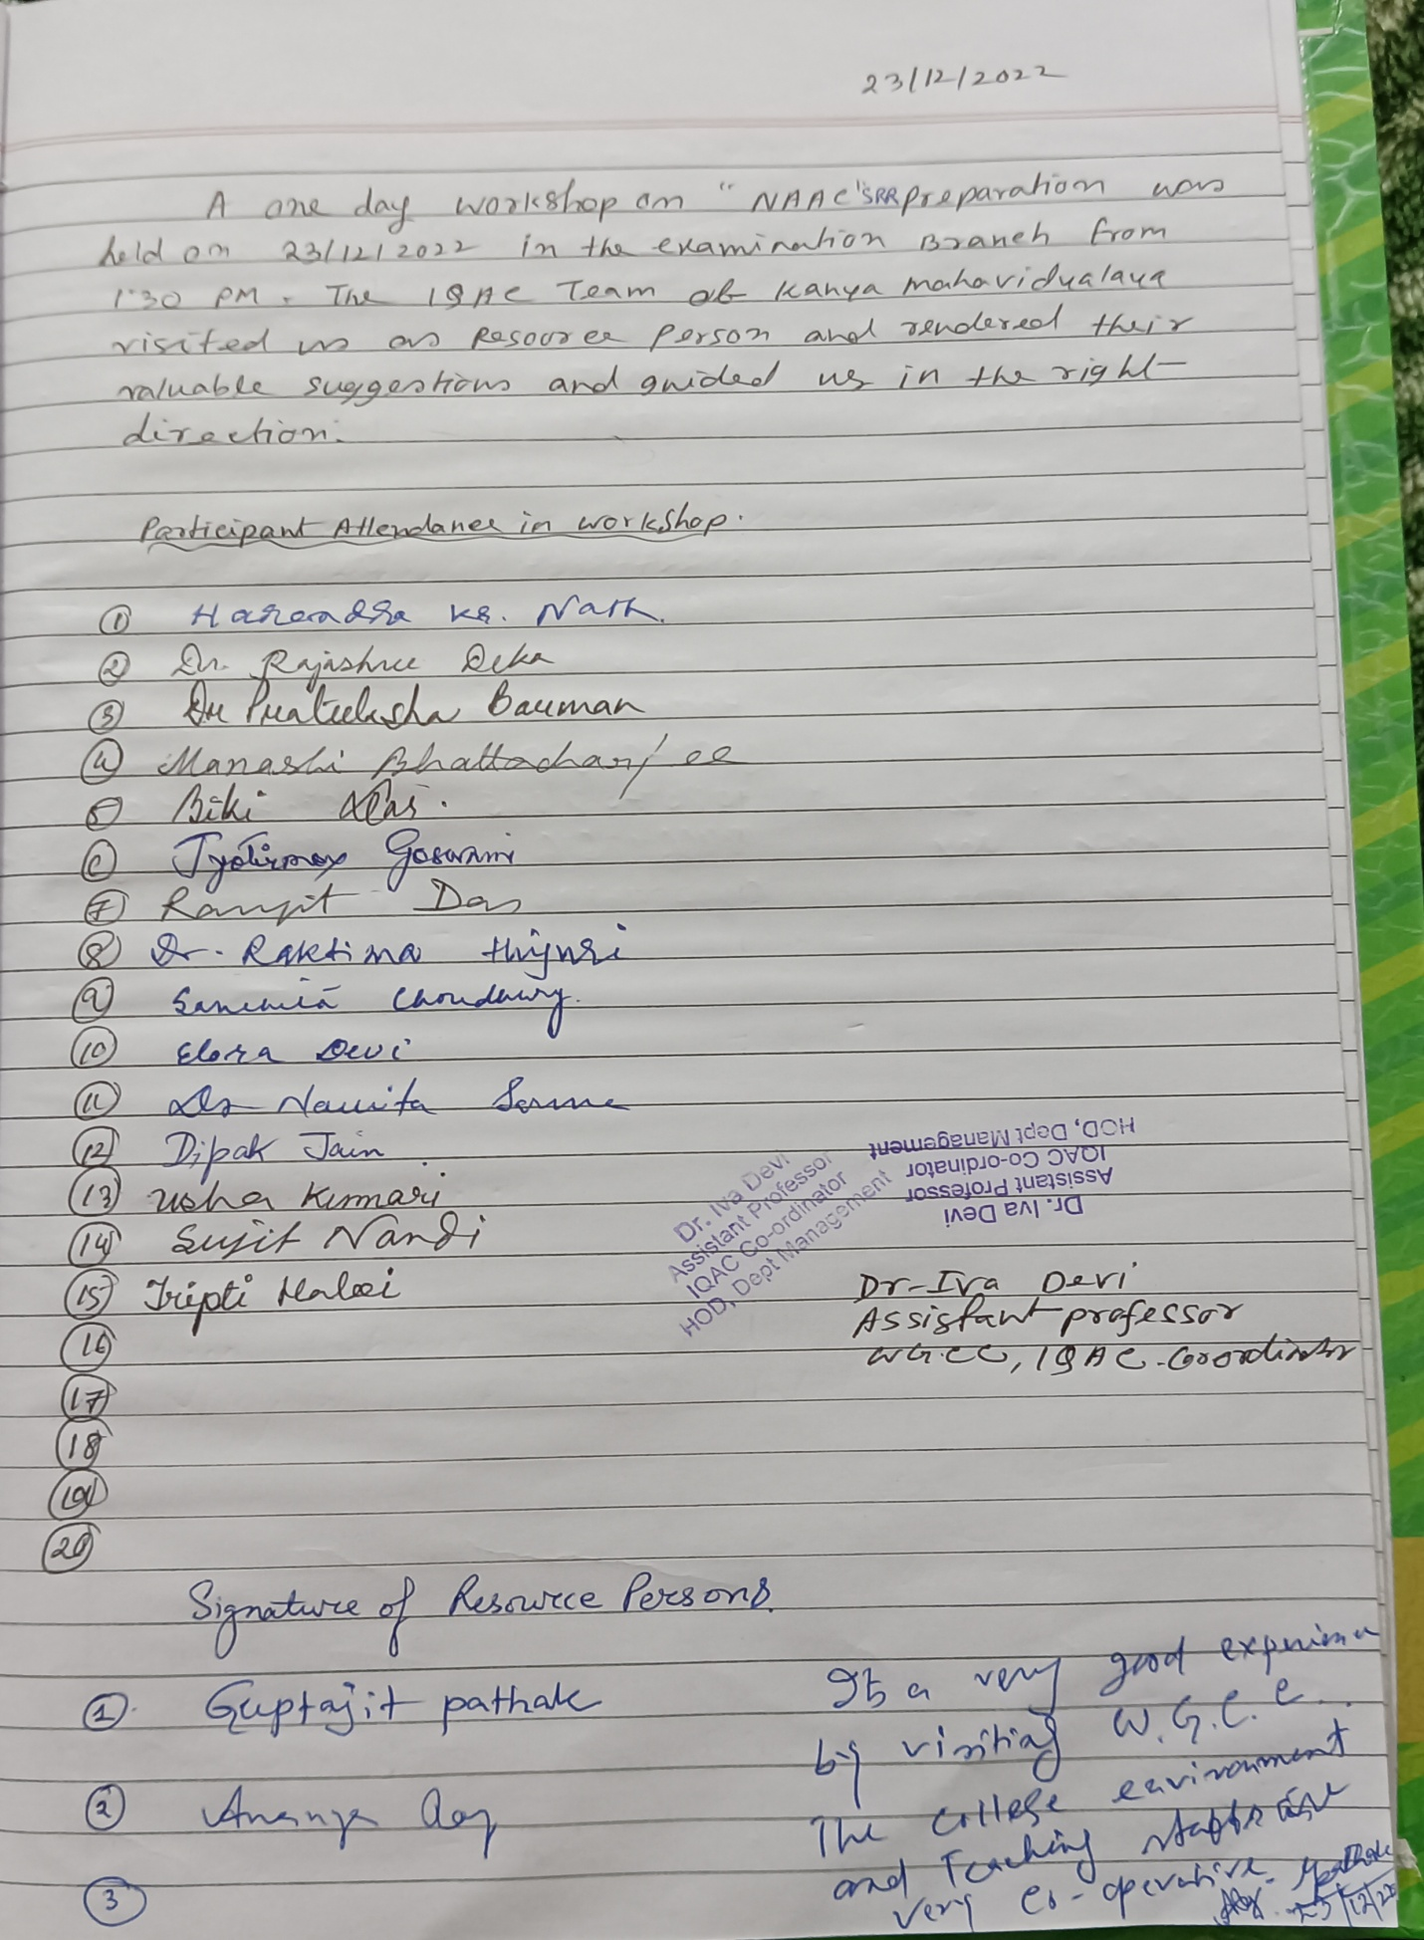

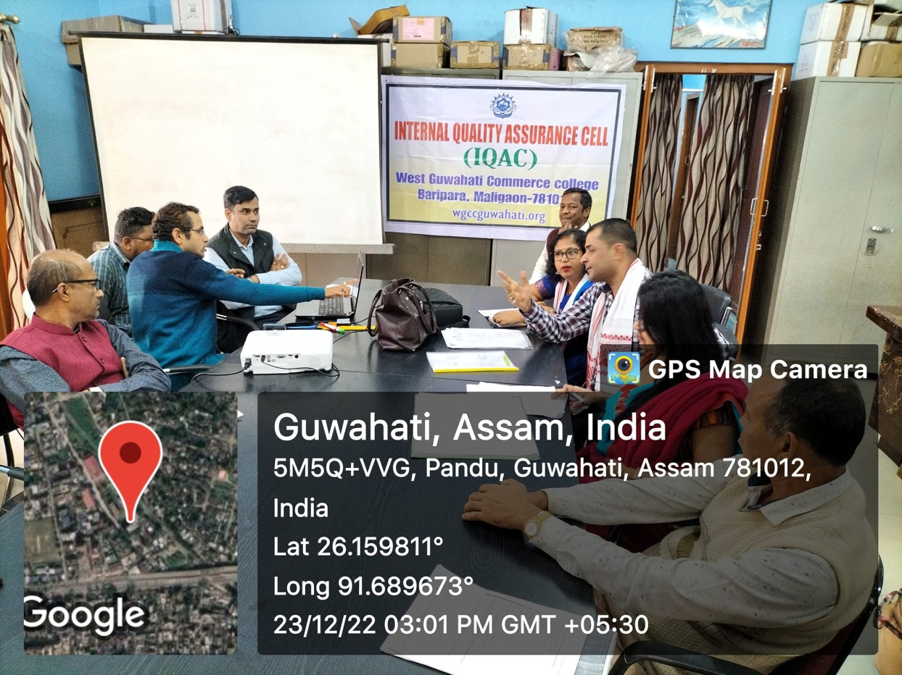

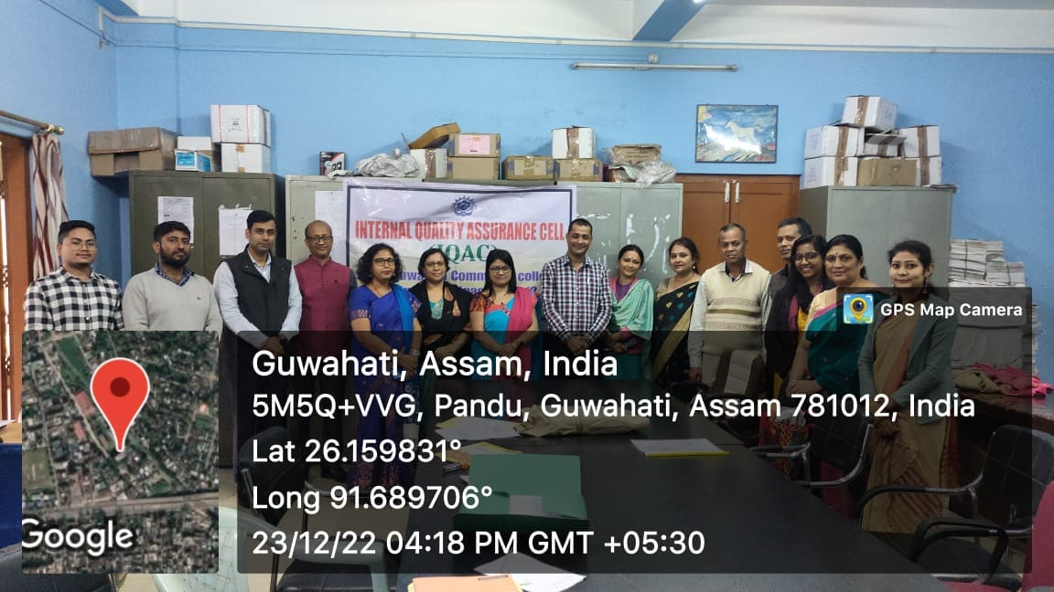

- Peer Mentoring with the first semester students on 5th December 2022
